Krish Gurung
2652393
LAB 1st task
4.4 TASK: Hotel Room Booking System
Requirements :- School of Architecture, Computing and Engineering
• Begin by modeling the customer’s request for a room. Follow the process as the hotel employee checks room availability, enters customer data, and verifies credit sufficiency. If successful, the booking is confirmed.
• Incorporate the capability for customers to modify or cancel reservations. Include steps for check-in, payment, and handling no-shows by applying a penalty charge.

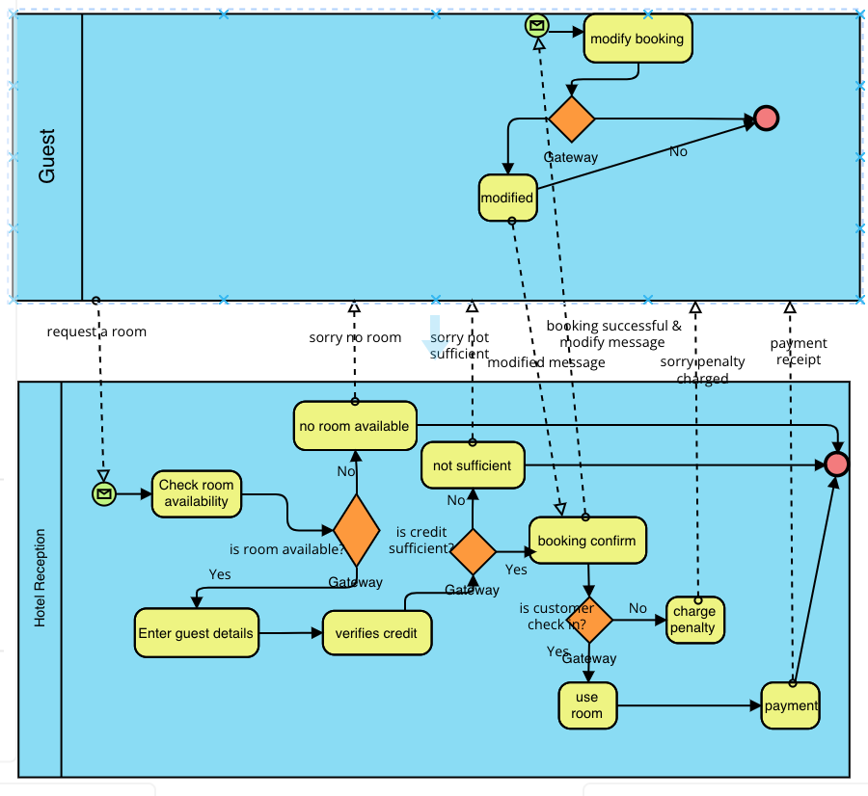
4.5 TASK: Product Management BPMN Diagram
Draw a BPMN diagram for the process below.
• When an order is received, check client data and availability in the inventory. Initiate a transaction to check if there is sufficient funds on the credit card supplied by the customer. Once the transaction is confirmed, then send a receipt to the customer as confirmation by email.
• Likewise, If the credit card data are ok, we should verify if the product is available in the inventory. Otherwise, fill order to buy. If the product is internally produced, start a production process and update the inventory.
